© Copyright , All rights reserved. Reproduction in whole or in part is prohibited without the prior written consent of the copyright owner. For any questions or remarks on this document, please contact , .
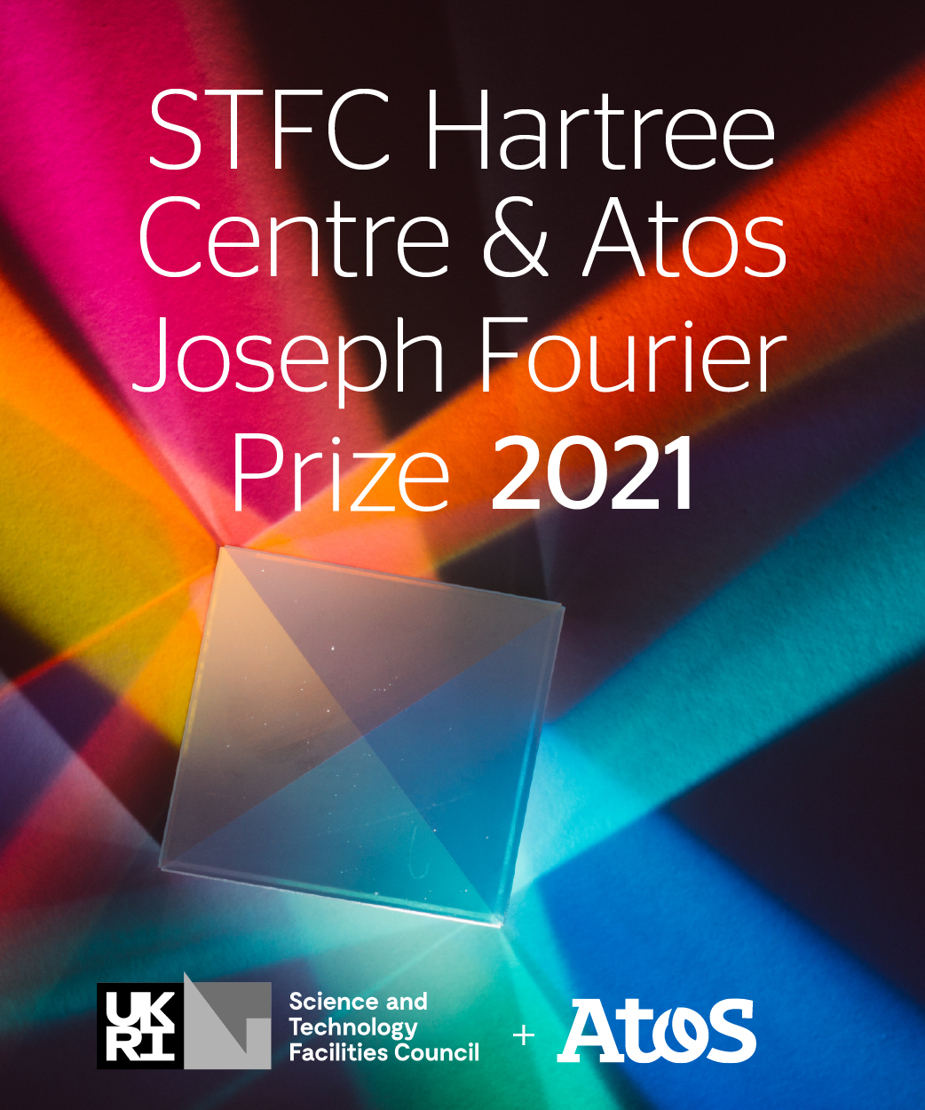
[Project name]

[Contest Category:]
Quantum Computing

[Last Name 1] / [First Name 1]
[Last Name 2] / [First Name 2]
[Last Name 3] / [First Name 3]

[Organization]

Table of Contents
1 CURRICULUM VITAE 5
1.1 General Information 5
1.2 Current position 5
1.3 Diploma 5
1.4 Professional curriculum 5
1.5 Skills 5
1.6 Further information 5
2 PUBLICATION LIST 6
3 CONTRIBUTION 7
3.1 Project/Research Description 7
3.2 Contribution of candidate (Or team) 7
3.3 Originality and difficulty 7
3.4 Similar work in the community 7
3.5 Validation and Tests 7
3.6 Direct and potential impacts 7
3.7 Deployment and Community Adoption 7
3.8 Next steps 7
3.9 Further information 7
4 WORK IMPACT 9
4.1 Item 1 9
4.2 Item 2 9
4.3 Item 3 9
4.4 Item 4 9
4.5 Item 5 9

HOW TO APPLY?

By participating in this contest, participants agree to abide by the terms and conditions – Rules - as established by Atos, which can be found on the competition webpage. Atos reserves the right to qualify all submissions and to reject any submissions that do not meet the requirements for participation as established by Atos.

The aim of this document is to explain how to apply to the STFC Hartree Centre and Atos Joseph Fourier Prize 2021.
If you have any further questions about the competition, please visit the competition webpage where you can also contact us.

Applying to the STFC Hartree and Atos Joseph Fourier Prize

Participants are invited to compete individually or in teams.

To apply, candidates or teams will be required to send the following application form completed including:
- Curriculum Vitae for each of the applicants
- Academic Curriculum for each of the applicants
- List of publications for each of the applicants
- Summary of the research/project

Applications should be sent to: atosfourier_UK@atos.net

CURRICULUM VITAE (not scored)

[2 pages maximum per team member]

General Information

Last Name:
First Name:
Address:

Phone Number:
E-mail address:

Current position

Please provide here any relevant information about your current position and your organization
(...)

Diploma

Tell us more about your academic background: highlight here the most important steps and achievements
(...)

Professional curriculum

If applicable, tell us more about your professional background: highlight here the main roles and positions you might have had.
(...)

Skills

Tell us more here about your skills in relation to the submission
(...)

Further information

Provide here any other relevant information: award, patent, collaboration, teaching, mentoring, etc.
(...)

PUBLICATION LIST (not scored)

In this section, provide the list of publications any of your team members participated in. Please highlight in this list the two most important publications to your project/research and explain why.
(...)

CONTRIBUTION

Describe in this section what gave rise to this application and detail: scientific excellence, scientific and societal spin-offs, algorithmic work and parallelization efforts, and demonstration of scalability function.
[22,500 characters maximum]

Project/Research Description

Present your project here and explain why you have applied to the STFC Hartree Centre and Atos Joseph Fourier Prize
(...)
[1,125 characters maximum]

Contribution of candidate (Or team)

(...)

Originality and difficulty

(...)

Similar work in the community

Explain here what makes your work stand out from previous research
(...)

Validation and Tests

Describe here the different steps of your project/research validation. It could be either experiments on large-sized cluster or validation from a wider community.
(...)

Direct and potential impacts

Describe here the direct and medium-term impacts of your work/research
(...)

Deployment and Community Adoption

(...)

Next steps

Describe here the next steps for your research/project.
(...)
[1,125 characters maximum]

Further information

Write here any other important information which you find relevant to your project
(...)
[1,125 characters maximum]

WORK IMPACT

Think of five items/achievements which best demonstrate the impact of your work and list them here.
It could be publications, software, events, and conferences. Explain why you selected these.
[2,250 characters maximum]

Item 1

(...)

Item 2

(...)

Item 3

(...)

Item 4

(...)

Item 5

(...)

Additional Materials

Please add any multimedia materials that will support your application, such as links to websites, videos, images, as an additional attachment whilst sending this application form for submission. If the materials exceed the attachment size limit, please provide a web link in the same email as this application, with a description of how to access the file and how it is relevant to your submission.

