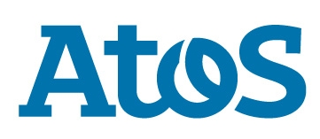

Press release

**Atos launches the most comprehensive Artificial Intelligence software suite available on the market to simplify and accelerate adoption of AI**

**Paris**, **July 3 2018 - Atos, a global leader in digital transformation, today announces Atos Codex AI Suite, the most comprehensive Artificial Intelligence (AI) software suite available on the market, to support businesses and research institutes in the development, deployment and management of AI applications. With Atos Codex AI Suite data scientists now have an easy-to-use, efficient and cost-effective solution to rapidly build and deploy artificial intelligence applications, better extract value from data and develop new business opportunities.**

Leveraging machine learning and deep-learning capabilities,Atos Codex AI Suite fosters a new generation of AI applications, which are able to sense, reason, act and adapt, to address a range of scientific, industry and enterprise challenges, in areas such as personal medicine, homeland security, smart cities and intelligent and autonomous data centers.

**First infrastructure agnostic** **solution on market**

Using Atos Codex AI Suite, apps can be deployed and relocated on multiple complementary environments:

* **Cloud**: on a wide variety of public Clouds, including AWS, Azure and Google Cloud, with which Atos [recently announced a global agreement](https://atos.net/en/2018/press-release_2018_04_24/google-cloud-and-atos-form-a-global-partnership),
* **On-premises**: on *any* server infrastructure, including on Atos’ [BullSequana S](https://atos.net/en/2017/press-release/general-press-releases_2017_11_09/atos-revolutionizes-enterprise-ai-with-next-generation-servers) server, **its** [BullSequana X](https://atos.net/en/products/high-performance-computing-hpc/bullsequana-x-supercomputers/bullsequana-x1000) **exascale-ready supercomputer and**
* 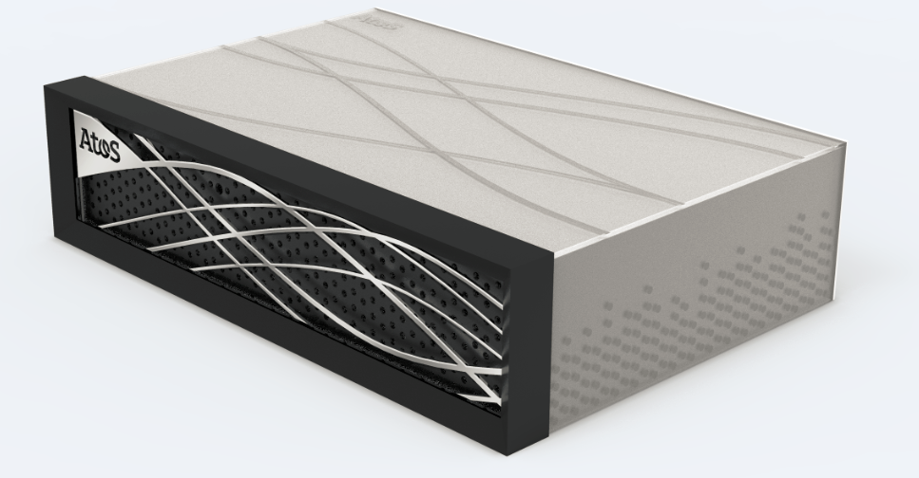**Edge computing: on Atos’ future edge computing box, one of the first of its kind worldwide, which** willenable businesses to extract and process valuable insight from data in real-time, close to the data source, to transform it into knowledge to support instantaneous decision-making while reducing costs. This break-through machine has a ruggedized design, allowing it to be used in any type of environment.

*“This**software suite is a new step forward to support our customers in their own digital transformation. Atos Codex AI Suite tackles new enterprise, scientific and industry challenges, such as precision medicine, advanced prescriptive maintenance and prescriptive security, with a new generation of cognitive applications, capable to address complex functions. It paves the way to new application domains and helps our customers to increase their business opportunities.”* says**Arnaud Bertrand, SVP, Strategy and Innovation BDS at Atos.**

**Key features and benefits**:

* **Accelerates time-to-market:** Using Atos Codex AI Suite’s secure, shared environment data scientists are able to use even the most complex applications by using qualified components, applications and trained models to improve quality and rapidly develop applications.
* **Delivers affordable performance:** Atos Codex AI Suite delivers **optimal performance** at the **lowest cost**,as only the most relevant resources are allocated. Cloud resources are used whenever possible and high-performance resources only when necessary.
* **Enables High-Performance Computing (HPC) and AI convergence:** HPC businesses can harness the benefits of AI, overcoming the limits of traditional simulations, to develop new applications in sectors such as precision medicine, prescriptive security and person recognition
* **Runs on multiple environments**: Cloud or on-premises to ensure fast allocation of resources and applications at any time.

**Availability**

Atos Codex AI Suite is available today, and can be purchased as a standalone software platform or together with a server infrastructure. Atos Codex AI Suite is Atos’ latest innovation as part of the [Atos Codex](https://atos.net/en/solutions/atos-codex-insight-driven-outcomes) portfolio.

***

**About Atos**

Atos is a global leader in digital transformation with approximately 100,000 employees in 73 countries and annual revenue of around € 12 billion. European number one in Big Data, Cybersecurity, High Performance Computing and Digital Workplace, the Group provides Cloud services, Infrastructure & Data Management, Business & Platform solutions, as well as transactional services through Worldline, the European leader in the payment industry. With its cutting-edge technologies, digital expertise and industry knowledge, Atos supports the digital transformation of its clients across various business sectors: Defense, Financial Services, Health, Manufacturing, Media, Energy & Utilities, Public sector, Retail, Telecommunications and Transportation. The Group is the Worldwide Information Technology Partner for the Olympic & Paralympic Games and operates under the brands Atos, Atos Consulting, Atos Worldgrid, Bull, Canopy, Unify and Worldline. Atos SE (Societas Europaea) is listed on the CAC40 Paris stock index.

**Press contact:**

Laura Fau | [laura.fau@atos.net](mailto:laura.fau@atos.net) | +33 6 73 64 04 18 | TWT[@laurajanefau](https://twitter.com/laurajanefau)