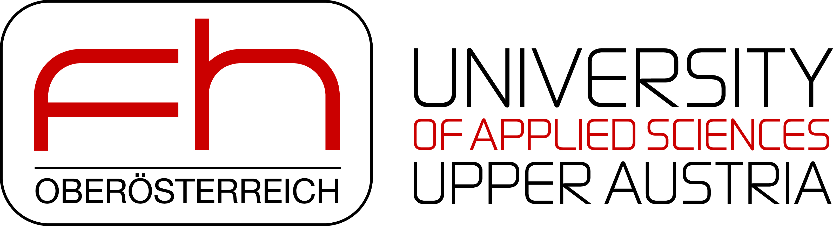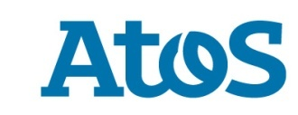 **Atos delivers new quantum simulator to leading University in Austria**

Press release

**Paris, July 2 2018 – Atos, a global leader in digital transformation, today announces a new contract with The University of Applied Sciences Upper Austria (FH Upper Austria) in Hagenberg for the latest version of its Atos Quantum Learning Machine, the** [**world's highest-performing commercially available quantum simulator**](https://atos.net/en/2017/press-release/general-press-releases_2017_07_04/atos-launches-highest-performing-quantum-simulator-world)**.** FH Upper Austria is the first Austrian University to use the Atos Quantum Learning Machine. It will help professors and researchers at the Department of Secure Information Systems with the analysis and development of new algorithms needed to improve cryptographic processes.

The Atos Quantum Learning Machine, designed by Atos through its quantum laboratory, [the first major quantum industry program in Europe](https://atos.net/en/2016/press-release_2016_11_06/atos-launches-atos-quantum-first-quantum-computing-industry-program-europe-2), enables researchers to run quantum simulation on premises, allowing users to develop and validate their quantum algorithms for future quantum accelerators with real QPU (Quantum Processor Units).

This new-look upgraded Atos Quantum Learning Machine is based on a new computing platform, which brings increased power and memory capabilities and is able to include accelerators which will augment power further. This latest version has advanced quantum hardware modeling capabilities, including [physics-based realistic qubit noise simulation](https://atos.net/en/2018/press-release/general-press-releases_2018_04_09/atos-announces-world-first-quantum-computing). By successfully modelling quantum noise, researchers will be able to bring qubit simulation closer to reality. This major step has been recognized by the Atos Quantum Scientific Council as a breakthrough in the quantum computing research field. The Atos Quantum Learning Machine is the first industrialised and turnkey quantum system capable of simulating up to 41 qubits. The Atos Quantum Learning Machine combines an ultra-compact system with a quantum software programming language based on the universal standard QASM (Quantum Assembly Language). Thanks to an in-memory based infrastructure the computing simulation capacity can be increased as needed at any stage.

With the support of the Quantum Learning Machine, the university will further strengthen its position as a European leader in information security with regard to education and research, and will also provide students with a future-oriented education for a new technology.

"*Over the next few decades, quantum computers will be able to tackle the explosion of data brought about by Big Data and the Internet of Things. Further significant advances in the areas of Deep Learning and Artificial Intelligence are also moving within reach”* says **Pierre Barnabé, Chief Operating Officer, Big Data & Security at Atos**.

*“The Atos Quantum Learning machine can help us master such challenges around security, and we’re pleased to be one of the first universities in Europe to work with*

***

**About Atos**

Atos is a global leader in digital transformation with approximately 100,000 employees in 73 countries and annual revenue of around € 12 billion. European number one in Big Data, Cybersecurity, High Performance Computing and Digital Workplace, the Group provides Cloud services, Infrastructure & Data Management, Business & Platform solutions, as well as transactional services through Worldline, the European leader in the payment industry. With its cutting-edge technologies, digital expertise and industry knowledge, Atos supports the digital transformation of its clients across various business sectors: Defense, Financial Services, Health, Manufacturing, Media, Energy & Utilities, Public sector, Retail, Telecommunications and Transportation. The Group is the Worldwide Information Technology Partner for the Olympic & Paralympic Games and operates under the brands Atos, Atos Consulting, Atos Worldgrid, Bull, Canopy, Unify and Worldline. Atos SE (Societas Europaea) is listed on the CAC40 Paris stock index.

**Press contact:**

Laura Fau | [laura.fau@atos.net](mailto:laura.fau@atos.net) | +33 6 73 64 04 18 | TWT[@laurajanefau](https://twitter.com/laurajanefau)

**About the Department of Secure Information Systems at the University of Applied Sciences Upper Austria**

The Secure Information Systems Department is part of the School of Informatics, Communications and Media at Hagenberg, one of four faculties of the University of Applied Sciences Upper Austria, the country’s largest HE institution of this kind. The department was founded in 2000. The expertise staff has acquired over the past 18 years has secured a reputation for high-quality education and as a sought-after partner for cutting-edge applied research by both industry and government. The department has three internationally accredited study programmes. In the field of IT security, there are full-time programmes for Masters and Bachelors degrees in Secure Information Systems, and there is also the option of a part-time Masters in Information Security Management. More than 1,600 students are currently studying at Hagenberg campus, majoring in 20 Bachelors and Masters degree programmes in informatics (computer science), communications and media. To date, more than 5,300 students have successfully graduated. The faculty’s research activities are closely linked to its focus on best-practice teaching. It has 11 research groups working on projects in three focus areas: information and communication systems, media and knowledge technologies, and software technology and applications. Founded in 1993 as part of a new wave of practice-oriented higher education institutions, Hagenberg has won an envied reputation as a leading centre for IT-related teaching and research. For further details see [www.fh-ooe.at/si](http://www.fh-ooe.at/si)

**Contacts at the FH Upper Austria Hagenberg Campus:**

Martina Anzinger (Marketing & PR) | [martina.anzinger@fh-hagenberg.at](mailto:martina.anzinger@fh-hagenberg.at) | +43 50804 21550

Robert Kolmhofer (Head of Department Secure Information Systems) | [robert.kolmhofer@fh-hagenberg.at](mailto:robert.kolmhofer@fh-hagenberg.at) | +43 50804 22510