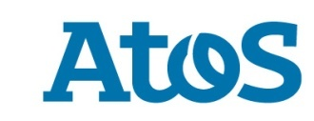**Atos announces its new quantum simulator**

Press release

**With 41 quantum bits (Qubits), the Atos Quantum Learning Machine is the highest-performing on the market**

**Paris, July 3 2018 – Atos, a global leader in digital transformation, today announced the latest version of its Atos Quantum Learning Machine (Atos QLM), more powerful and scalable, with a doubled power capacity and the ability to simulate physical Qubits.** The Atos Quantum Learning Machine is the first commercially available and ready-to-use quantum system, capable of simulating up to 41 quantum bits (Qubits).

Just one year after its launch, the Atos Quantum Learning Machine has had a strong commercial success with universities, research laboratories and companies: at the US Department of Energy’s Oak Ridge National Laboratory, in France (at the CEA and the University of Reims) in the Netherlands, in Germany and most recently at [the University of Applied Sciences in Upper Austria.](https://atos.net/en/2018/press-release/general-press-releases_2018_07_02/atos-delivers-new-quantum-simulator-leading-university-austria)

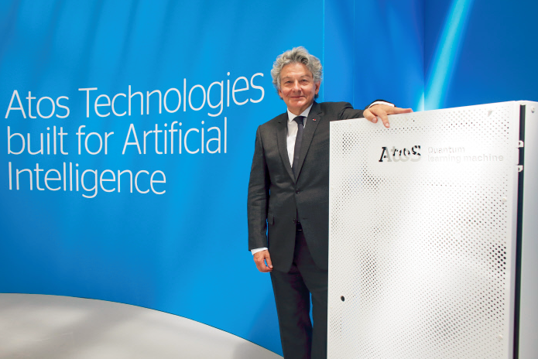

Today, at the third edition of Atos Technology Days, Thierry Breton, CEO and Chairman of the Atos Group, presented the new version of the Atos Quantum Learning Machine, incorporating several new features from the Atos R&D Laboratory and supported by a [world-renowned Scientific Council](https://atos.net/en/2017/press-release/general-press-releases_2017_06_01/atos-sets-milestones-future-atos-quantum-program-scientific-council):

* **Two times more powerful**: now with the ability to simulate 41 Qubits, the Atos Quantum Learning Machine, which was already the most powerful simulator in the world with 40 Qubits, has now doubled in power. This version of the Atos Quantum Learning Machine is based on a new computer platform that delivers increased power and memory capabilities and is able to include accelerators which will augment power further.
* **The integration of "quantum noise":** this latest version now has enhanced hardware modeling capabilities, including modeling "[quantum noise](https://atos.net/en/2018/press-release/general-press-releases_2018_04_09/atos-announces-world-first-quantum-computing)", which enables researchers to bring qubit simulation closer to reality. This major step has been recognized by the Atos Quantum Scientific Council as a significant breakthrough in the quantum computing research field.

Designed by Atos through its quantum laboratory, [the first major quantum industry program in Europe](https://atos.net/en/2016/press-release_2016_11_06/atos-launches-atos-quantum-first-quantum-computing-industry-program-europe-2) launched in November 2016, the Atos Quantum Learning Machine enables researchers worldwide to run quantum simulations on premises, and to develop and validate their quantum algorithms for future quantum accelerators with real QPU (Quantum Processor Units).

**Thierry Breton, CEO and Chairman of Atos**, said: *"Atos, through the launch of its Atos Quantum program in November 2016, is the quantum computing pioneer in Europe, supported by a world-renowned scientific council composed of Nobel Prize and Fields Medal laureates and the best international experts in this field”* said *“We are already anticipating the ‘digital tsunami’ that may be represented by quantum computing, compared to the wave of digital transformation that we are currently experiencing. To help researchers and companies prepare for it, I am delighted to unveil – on the occasion of Atos Technology Days 2018 – the new version of the Atos QLM, now with a power of 41 Qubits. It also incorporates world-firsts in terms of simulating ‘quantum noise’ in order to make the simulation even more realistic. These advances – combined with our work to develop a quantum accelerator within five years – place Atos and its customers in an ideal position to take advantage of future digital revolutions.”*

Atos has already delivered a first copy of its new quantum simulator to the Austrian University FH Oberösterreich (Hagenberg), which will help professors and researchers at the Department of Secure Information Systems with the analysis and development of new algorithms needed to improve cryptographic processes.

***

**About Atos**

Atos is a global leader in digital transformation with approximately 100,000 employees in 73 countries and annual revenue of around € 12 billion. European number one in Big Data, Cybersecurity, High Performance Computing and Digital Workplace, the Group provides Cloud services, Infrastructure & Data Management, Business & Platform solutions, as well as transactional services through Worldline, the European leader in the payment industry. With its cutting-edge technologies, digital expertise and industry knowledge, Atos supports the digital transformation of its clients across various business sectors: Defense, Financial Services, Health, Manufacturing, Media, Energy & Utilities, Public sector, Retail, Telecommunications and Transportation. The Group is the Worldwide Information Technology Partner for the Olympic & Paralympic Games and operates under the brands Atos, Atos Consulting, Atos Worldgrid, Bull, Canopy, Unify and Worldline. Atos SE (Societas Europaea) is listed on the CAC40 Paris stock index.

**Press contact:**

Sylvie Raybaud – [sylvie.raybaud@atos.net](mailto:sylvie.raybaud@atos.net) - +33 6 95 91 96 71 - TWT[@Sylvie_Raybaud](https://twitter.com/Sylvie_Raybaud)