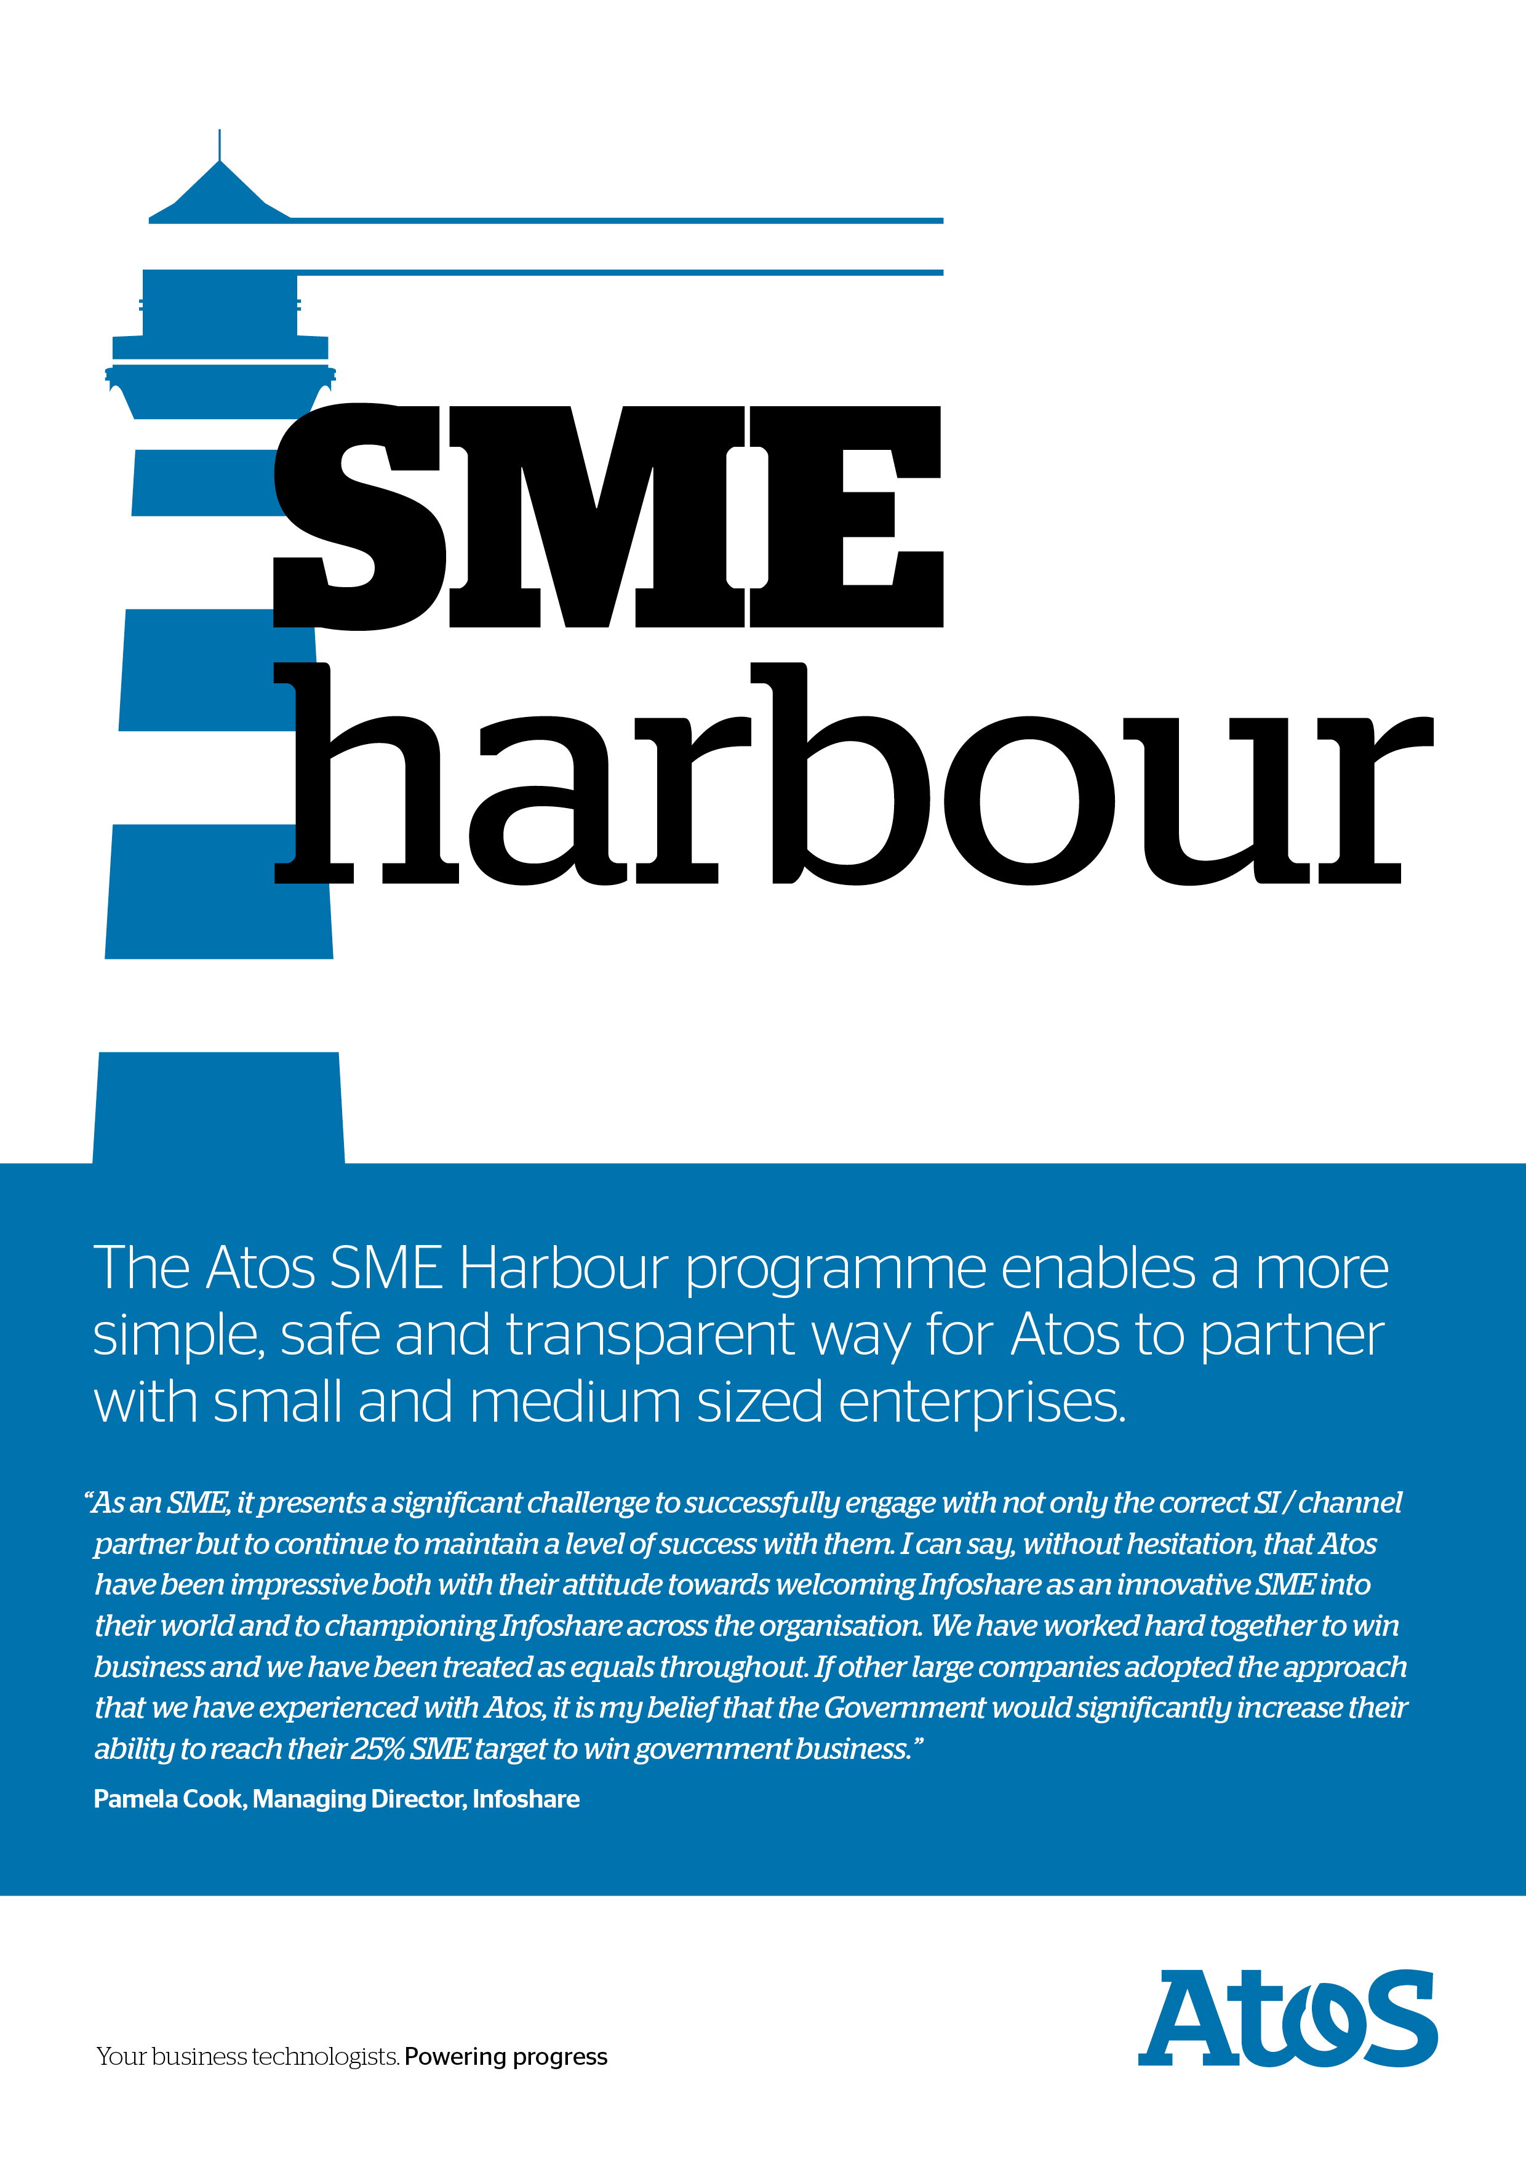
SME - Partner Application Form

Company name:
Contact name:
Position:
Telephone:
Email:
Website:
Date of Application:
We would like to understand your proposal. Please include detail such as any potential innovation for our clients, the products and / or services you offer and how you believe such a partnership would be of benefit to both organisations.
- Products and Services
In order to develop our understanding we’d like to hear more about your product range, functional areas and systems environment they operate in. Please also inform us of any services you provide to support your products, such as implementation services, training and maintenance.
Feel free to attach brochures or technical information leaflets, however if you do please reference them.

- Target Clients and Markets
Please state your target markets including industry sector and also a typical profile of a customer who you are aiming to sell to.
- Analyst Positioning and Client References
In this section we’re looking for any recent analyst views of your company, market, positioning and products, along with any client references.
- Type of Business, Objectives and Strategy
Here we would to understand more about your core business, what your key objectives are for the mid-term and your company strategy. We’d like to understand your Unique Selling Points and how you deliver customer solutions.

- Partner Strategy
We treat partners as an extension of ourselves and value them highly. Please list and describe the types of partners you have, including resellers, system integrators and business consultancies. We’d like to know the expectations you have from different partners, particularly with respect to generating sales. We’d also like your opinion on how the proposed partnership with Atos would fit into your current partnering strategy.
- Company Organisation and History
Tell us how your company is structured, the number of staff, and how your revenue is split, along with a brief history of your business.
Please email completed form to: SMEHarbour.it-solutions@atos.net

